**Deploying Single node openshift cluster in vmware workstation using dns server.**

We will be need 3 server here:

1 > DNS

2 > Bastion Node

3 > SNO Node

|  |  |  |  |
| --- | --- | --- | --- |
| NAME | DNS | BASTION NODE | SNO NODE |
| RAM | 4 | 8 | 24 |
| CPU | 4 | 8 | 16 |
| DISK | 30 | 30 | 250 |

On DNS server.

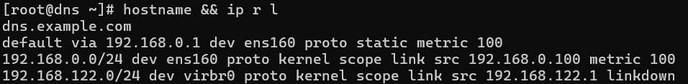

mkdir -p /var/named/chroot/var/named/

touch /var/named/chroot/var/named/example.com

touch /var/named/chroot/var/named/192.168.0.rev

chmod -R 777 /var/named/chroot/var/named/*

yum install git -y

git clone <https://github.com/khalifullah/ocp.1.git>

cd ocp.1/Home-Sno/

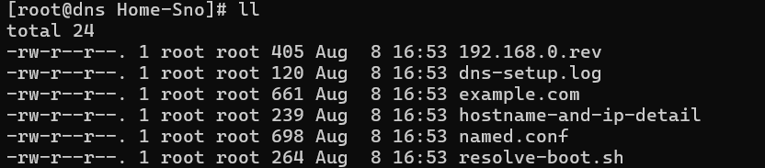

scp -rv 192.168.0.rev /var/named/chroot/var/named/

scp -rv example.com /var/named/chroot/var/named/

scp -rv named.conf /etc/named.conf

mkdir -p /root/home-dns/

scp -rv resolve-boot.sh /root/home-dns/

**Replace the ip and hostname as per the env.**

Verify using dig:





**DNS COMPLETED**

Install and configure bastion node with oc utility and ssh-key once all sno prerequisite is completed then go with installation of openshift cluster.

Once installation is completed deploy a simple application.

oc new-project hello-openshift

oc new-app openshift/hello-openshift --name=hello-openshift

oc get pod,svc

oc expose service/hello-openshift